**PROBLEM 1**

**Initial Requirements**

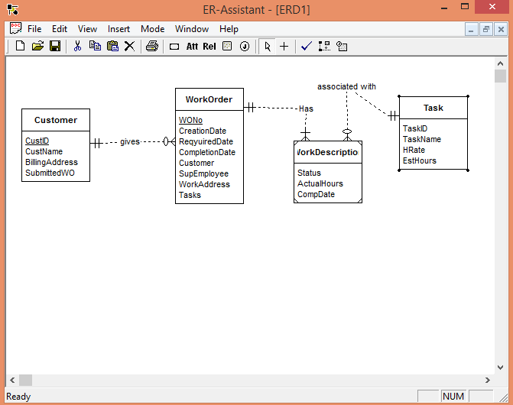

**Revised ERD:**

